**Project Documentation:**

**Week 3 – Task 2:**

***Clone Website***

**Submitted By: Zara Khan**

**Submitted To: A&D Tech**

**Dated: 24th July, 2024**

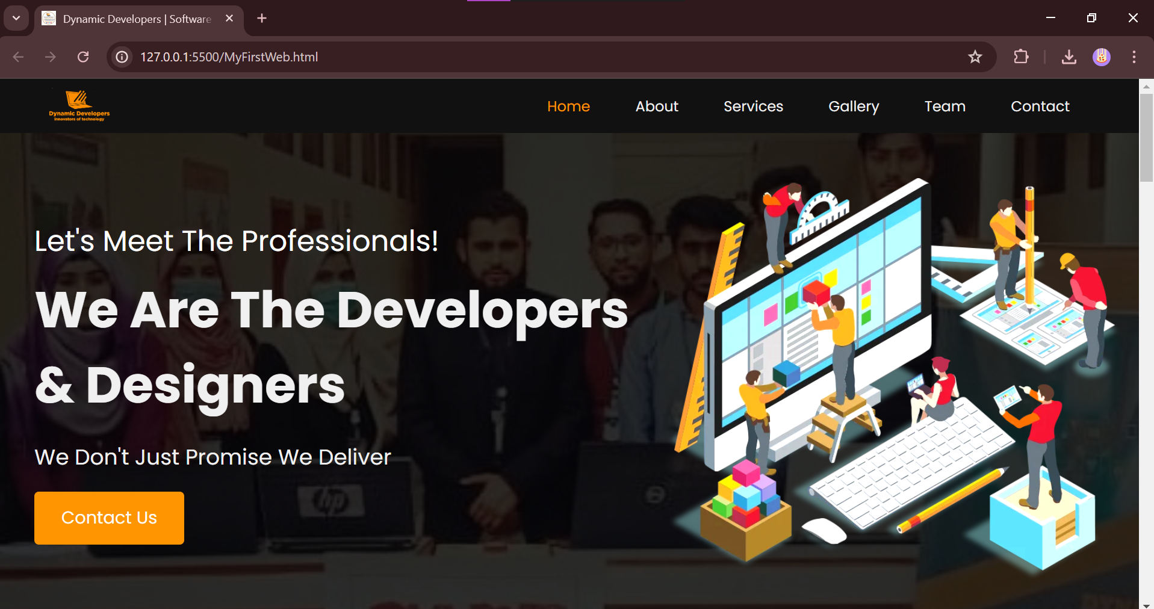

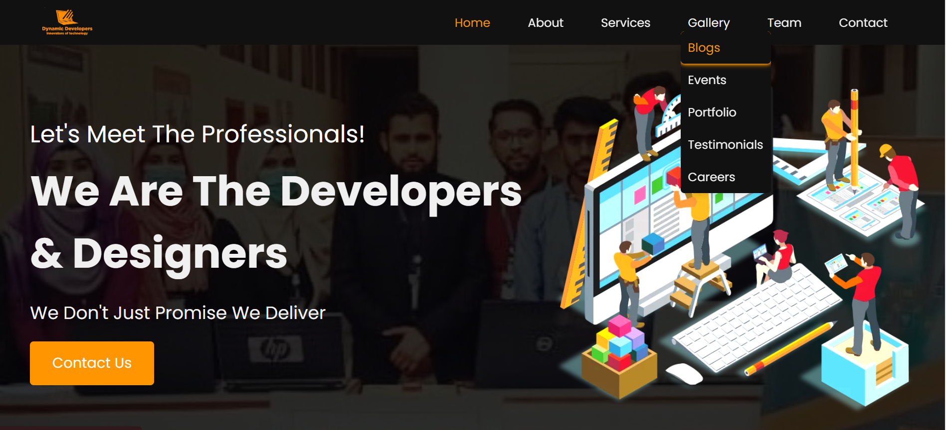

***About-Us Section***

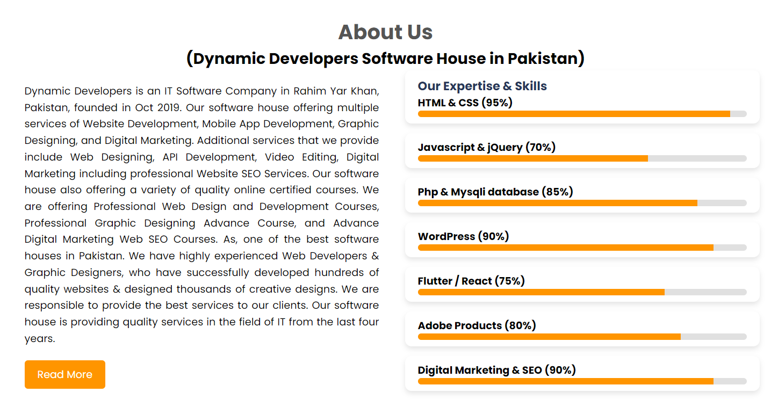

***Our Services-Section***

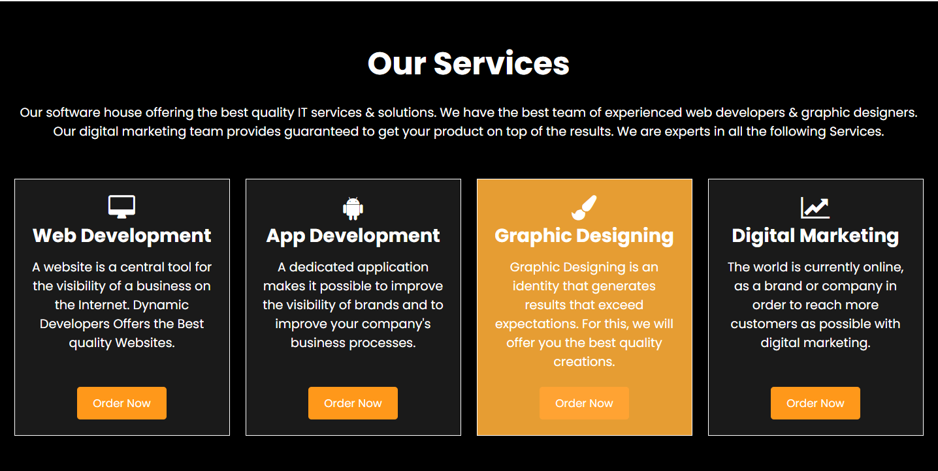

***Our Team-Section***

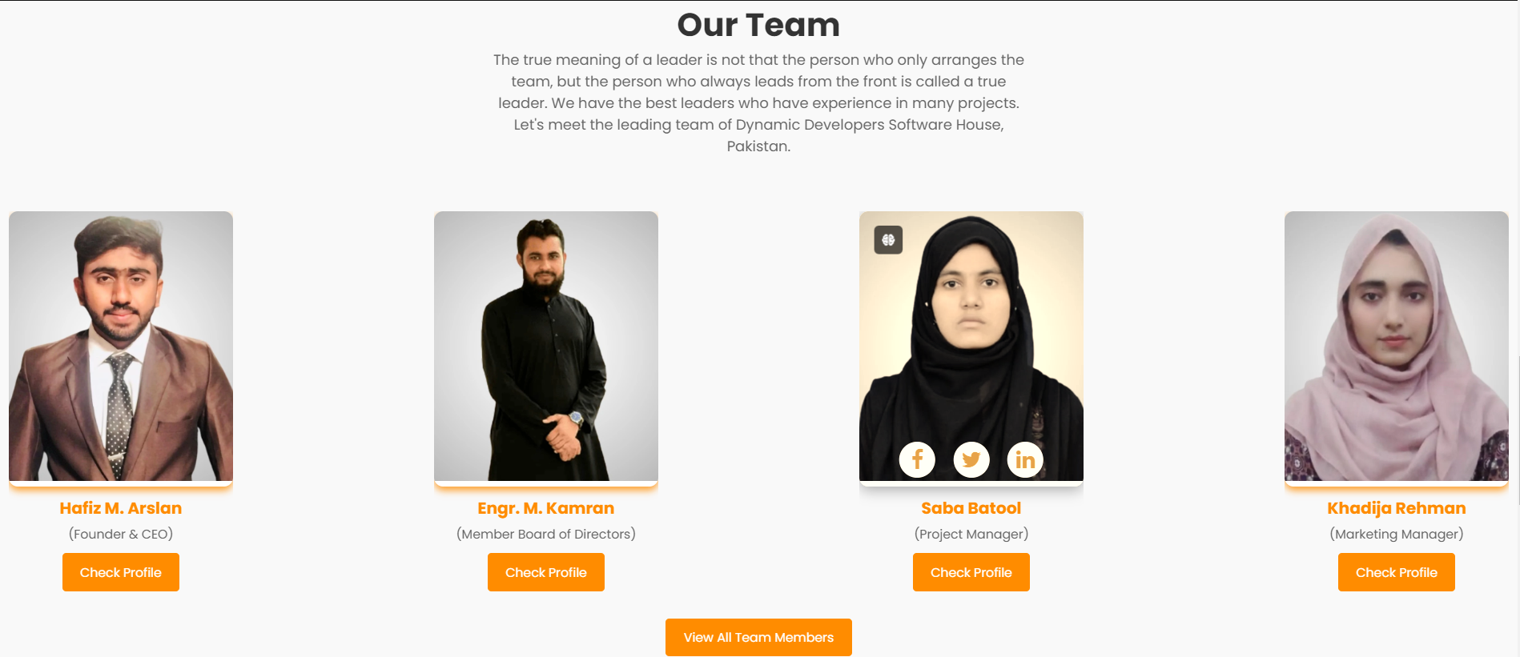

***Contact-Section***

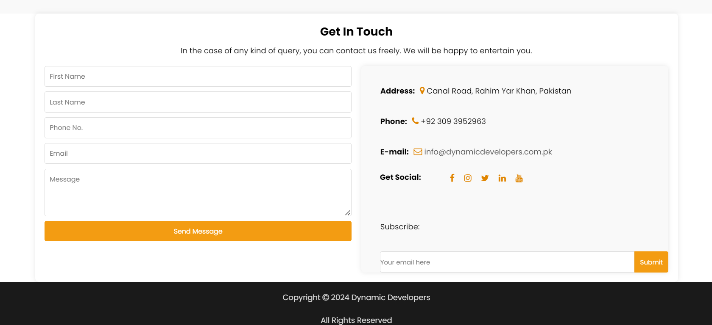

***Problem Statement***

In week 3.2, you have to clone this website and give name your website as "MyFirstWeb”, Dynamic Developers | Software House in Pakistan - IT Company.

***Solution Overview***

I started out by looking at the different sections and making them one by one, doing all the required changes and then adding them together. Some layouts and features were difficult to understand but somehow I was able to manage them.

***Challenges and Resolutions***

**Challenge: Drop-down List**

* **Initial Issue**: To make a dropdown list from another dropdown list.
* **Approach**: I tried various CSS techniques and changed my html structure.
* **Resolution**: Unfortunately, whatever I tried even with help from internet I could not understand why that feature was not working.

**Challenge: Form Layout**

* **Initial Issue**: To adjust the form layout in a left and right div.
* **Resolution**: With the help of various CSS techniques and div containers I made it look like the original website but still some properties were not adjusting well.

***Instructions***

**Setting Up the Project**

1. **Download the Project Files:**
   * Clone the repository from GitHub.
   * Alternatively, download the project zip file and extract it to your local machine.
2. **Open in Visual Studio Code (VS Code):**
   * Launch VS Code.
   * Open the entire project folder using File > Open Folder.

**Running the Project**

1. **Navigate to the Main Page:**
   * In the VS Code sidebar, locate and open MyFirstWeb.html.
2. **Testing Responsiveness:**
   * Use VS Code's built-in preview or open the website in different browsers and devices to ensure responsiveness.